CURRENT IMPLEMENTATION NOTICE — October 2026: The original Streamlit deployment description in this PRD is superseded. BuildPay AI is now implemented as a Next.js/React web application with a FastAPI backend and PostgreSQL, deployed to Microsoft Azure.
BUILDPAY AI
Product Requirements Document
AI-Assisted Construction Payment & Work Approval Platform
Document Control | Value
Version | 1.0
Status | Product Requirements / Baseline
Date | 03 October 2026
UI | Streamlit
AI Orchestration | CrewAI
LLM | Groq / openai/gpt-oss-120b
Deployment | GitHub + Streamlit Community Cloud
Authority | Human decision-makers

Core principle: AI prepares, checks, calculates and flags; humans authorize.

Table of Contents
1. Executive Summary 2
2. Product Vision 2
3. Problem Statement 3
4. Goals and Objectives 3
5. Scope 3
6. Users and Human Roles 4
7. AI Workforce 4
8. End-to-End Workflow 5
9. Functional Requirements 6
10. BOQ Management 7
11. Check Request Management 7
12. Document & Evidence Management 7
13. Work Execution & Measurement 8
14. Variation Management 8
15. IPC Management 8
16. Human-in-the-Loop Approval 9
17. Records, History & Audit Trail 9
18. UI/UX Requirements 10
19. Data Model 10
20. Agent & Tool Architecture 11
21. Non-Functional Requirements 11
22. Security & Governance 11
23. Reporting & Analytics 12
24. Deployment & Technical Stack 12
25. MVP Acceptance Criteria 12
26. Risks & Mitigations 13
27. Future Roadmap 13
28. Open Decisions 14
29. Glossary 14

1. Executive Summary
BuildPay AI is a multi-agent construction payment and work-approval platform for contractors, consultants, quantity surveyors, clients and authorized project personnel. It manages BOQ activities, Check Requests, supporting evidence, measurements, quantity variations, Interim Payment Certificates (IPCs), historical records and approvals. CrewAI orchestrates specialist agents; Groq provides the LLM; Streamlit provides the user interface.
The system is human-controlled. AI agents may extract information, perform deterministic calculations through tools, compare records, identify exceptions, prepare summaries and generate drafts. AI agents must never independently approve work, approve variations, approve IPCs or release payment.

2. Product Vision
Create a transparent, auditable and modular digital workforce that reduces manual construction-payment administration while preserving contractual authority and human accountability.
- One controlled workflow from BOQ activity through Check Request, execution, variation and IPC.
- Evidence-based AI review with explicit missing-evidence warnings.
- Clear separation between AI recommendation and human authorization.
- Historical traceability for quantities, approvals, variations and IPCs.
- Simple role-based UI for Contractor, Consultant and Client.
- Modular specialist agents maintained independently.

3. Problem Statement
Construction payment administration often relies on fragmented spreadsheets, email, scanned documents and manual reconciliation. This creates duplicate effort, weak traceability, late discovery of quantity overruns and difficulty proving how a certified amount was derived.
- Link requests to exact BOQ activities.
- Check quantities against original and approved revised quantities.
- Maintain a formal Variation Register.
- Generate IPC drafts only from eligible approved work.
- Preserve AI findings and human decisions.
- Surface missing evidence and duplicate/overrun risks before certification.

4. Goals and Objectives
Goal | Success measure
Reduce administration | Less manual preparation/reconciliation for routine workflows.
Improve traceability | Every CR, variation and IPC links to BOQ, evidence and approvals.
Control overruns | Potential overrun is flagged before unsupported quantities enter an IPC.
Preserve authority | No AI-only approval or payment release.
Improve evidence completeness | Required documents are tracked by workflow stage.
Maintainability | Nine clearly bounded specialist agents.

5. Scope

5.1 In Scope
- Double-storey residential BOQ templates for 5 marla, 10 marla and 1 kanal.
- Civil works only: mobilization, grey structure and finishing.
- Contractor, Consultant and Client workspaces.
- BOQ activity selection and quantity management.
- Check Request creation, evidence upload and AI review.
- Work execution and measurement capture.
- Variation identification, summary, submission and approval.
- Variation Register and historical reconciliation.
- IPC generation, review and human approval.
- Persistent records and audit trail.

5.2 Out of Scope for MVP
- Automatic bank/payment execution.
- AI contractual approval.
- Full ERP/accounting integration.
- Legal determination of claims/entitlement.
- Automated site-sensor integration.
- Certified engineering measurement without human verification.
- OCR/vision certification replacing human review.

6. Users and Human Roles
Role | Responsibilities
Contractor | Submit CRs, quantities, evidence, variation requests and executed quantities.
Consultant / Engineer | Technical review, measurement/evidence verification and recommendations.
Quantity Surveyor / Commercial Engineer | BOQ/rate reconciliation, variations, cumulative quantities and IPC review.
Client / Employer Representative | Human approval authority for work, variations and IPCs according to the project matrix.
Project Manager / Authorized Approver | Escalation and delegated approval of exceptional/high-value items.

7. AI Workforce
# | Agent | Responsibility
1 | BOQ & Activity Agent | Structures BOQ items, activities, units and original quantities.
2 | Check Request Agent | Prepares and validates Check Requests against approved BOQ activities.
3 | Document & Evidence Agent | Checks required documents and identifies missing/inconsistent evidence.
4 | Measurement & Quantity Agent | Checks requested/executed and cumulative quantities.
5 | Contract Compliance Agent | Checks supplied contract/specification requirements.
6 | Variation in Quantity Agent | Identifies overruns, calculates additional quantities, summarizes justification and submits variations.
7 | History & Duplicate Detection Agent | Compares current records with prior CRs, variations and IPCs.
8 | IPC Preparation & Reconciliation Agent | Prepares IPC drafts from approved eligible work and reconciles values.
9 | Review & Audit Agent | Consolidates findings and prepares human review/audit packages.

8. End-to-End Workflow
- Load/select the project BOQ and activity.
- Contractor creates a Check Request linked to a BOQ item.
- Contractor enters requested quantity and uploads evidence.
- AI agents review BOQ linkage, evidence, quantity and compliance.
- Review & Audit Agent prepares a consolidated brief.
- Authorized human approves, returns or rejects the Check Request.
- Approved work is executed.
- Actual measurement and evidence are recorded.
- AI compares actual/cumulative quantity with approved quantity.
- If an overrun exists, a Variation Request is created.
- Variation is reviewed and approved/returned/rejected by a human.
- Only approved variations affect IPC eligibility.
- IPC draft is generated and reconciled.
- AI reviews IPC.
- Authorized human approves or returns IPC.
- Records remain available for history and audit.

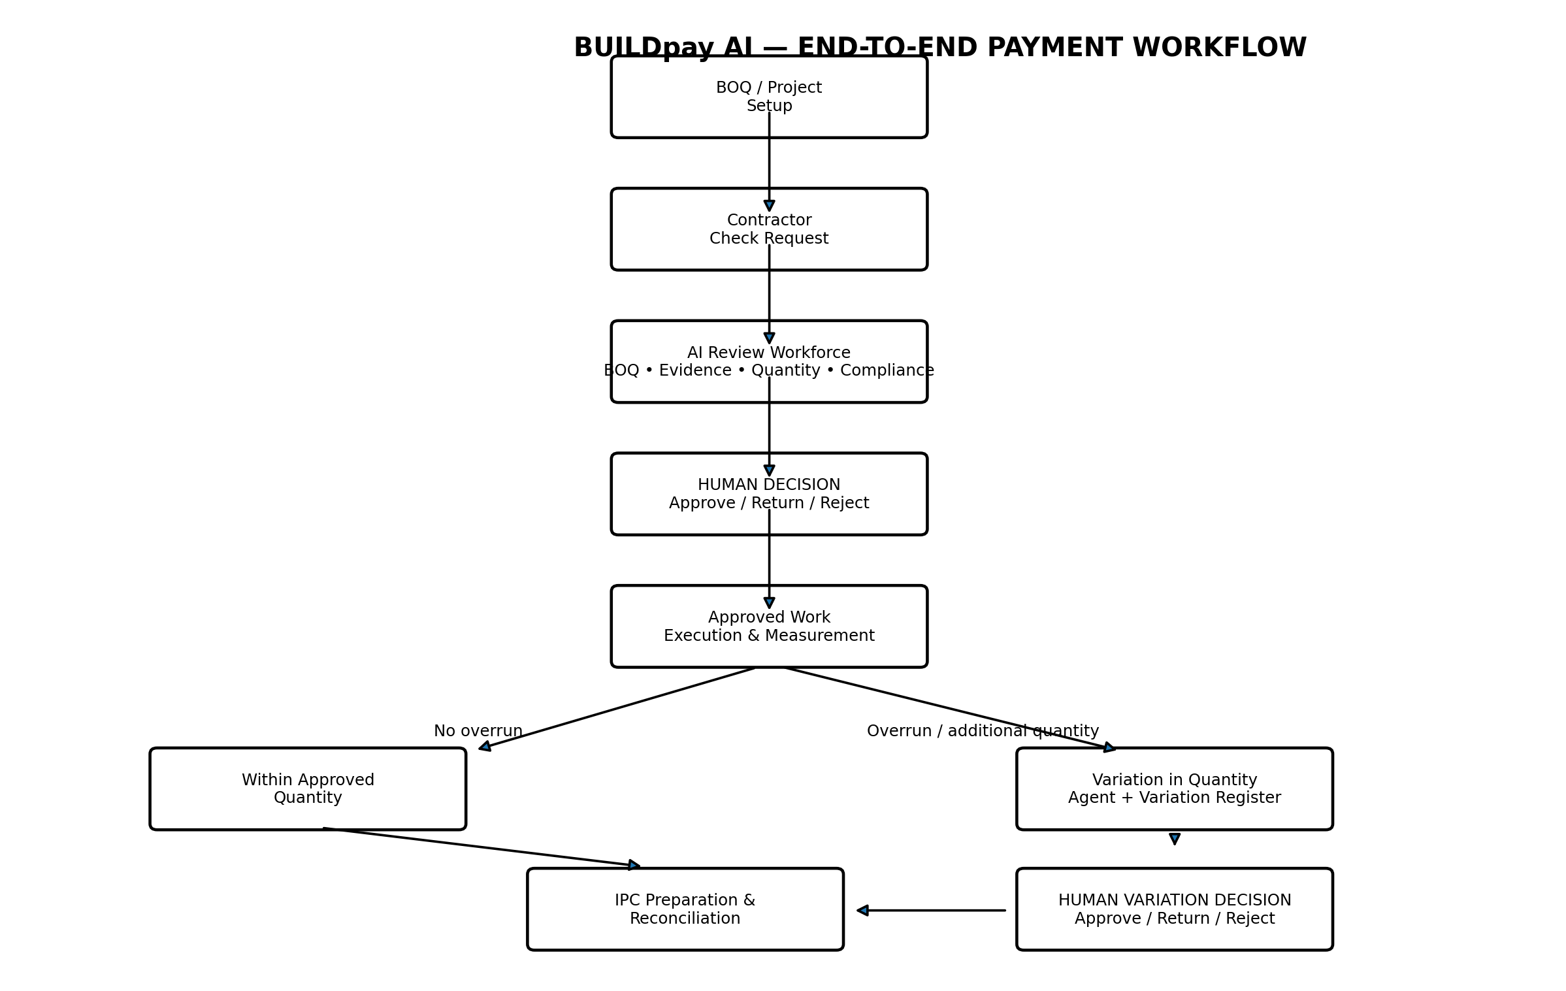

Figure 1. End-to-end BuildPay AI workflow, including the human approval gates.
The following flowchart defines the controlled lifecycle. AI agents support analysis and preparation; human decision gates remain authoritative.

9. Functional Requirements
ID | Requirement
FR-01 | Provide Contractor, Consultant and Client workspaces.
FR-02 | Select 5 marla, 10 marla or 1 kanal double-storey civil BOQ.
FR-03 | Create CR linked to an exact BOQ item.
FR-04 | Upload and associate supporting documents.
FR-05 | Run AI review and display current working agent.
FR-06 | Human can approve, return or reject CR.
FR-07 | Capture executed/current quantities and evidence.
FR-08 | Detect quantity overruns.
FR-09 | Create and maintain Variation Register records.
FR-10 | Only authorized humans approve variations.
FR-11 | Unapproved overruns cannot enter IPC eligibility.
FR-12 | Generate IPC draft from eligible approved work.
FR-13 | Human can approve/return IPC.
FR-14 | Retain CR, variation and IPC history.
FR-15 | Record material workflow actions in audit history.

10. BOQ Management
MVP templates cover double-storey houses and only civil works: 5 marla, 10 marla and 1 kanal; mobilization, grey structure and finishing.
BOQ templates are illustrative planning/tender templates and must be validated against actual drawings, specifications, site conditions and applicable requirements before contractual use.
- Item code
- Section
- Description
- Unit
- Original quantity
- Unit rate
- Amount
- Notes

11. Check Request Management
A Check Request is the formal request to authorize/review a defined BOQ activity.
Field | Purpose
CR number | Unique identifier
Project | Project association
BOQ item | Exact activity reference
Requested quantity | Proposed execution quantity
Unit | Measurement unit
Description | Execution context
Required documents | Evidence checklist
AI findings | Automated review
Human decision | Approve / Return / Reject
Approval metadata | Person, timestamp and comments

12. Document & Evidence Management
- Associate documents with project and relevant CR, variation or IPC.
- Support PDF, DOCX, XLSX, CSV, TXT and Markdown in the MVP.
- Track uploaded, reviewed, missing and rejected evidence.
- Uploading a document does not mean it has been verified.
- AI must explicitly state when evidence is unavailable or insufficient.

13. Work Execution & Measurement
After human approval, work proceeds according to the project's authorized workflow. Executed quantities are subsequently captured for measurement and IPC preparation.
- Current quantity
- Previously certified quantity
- Cumulative quantity
- Remaining approved quantity
- Measurement evidence
- Measurement date
- Verifier
- Comments

14. Variation Management
The Variation in Quantity Agent identifies quantity overruns, calculates the proposed additional quantity, summarizes justification and submits a variation for human approval. It cannot approve a variation.
Field | Description
Variation number | Unique variation identifier
Linked CR | Originating Check Request
BOQ item | Affected activity
Original BOQ quantity | Original quantity
Previously approved variation | Prior approved addition
Current approved quantity | Original plus approved variations
Previously certified quantity | Cumulative certified quantity
Required cumulative quantity | Quantity needed based on measurement
Proposed additional quantity | New variation requested
Revised proposed quantity | Current approved quantity plus proposed addition
BOQ rate | Applicable rate
Estimated variation value | Additional quantity × rate
Justification | Reason for variation
Evidence | Supporting documents
Status | Draft / Submitted / Review / Approved / Returned / Rejected
Human approval | Approver, date and decision

Control rule: an unapproved variation must not silently increase quantity eligible for an IPC.

15. IPC Management
IPC generation is restricted to work that has passed required approval and quantity controls.
- Link IPC to approved CRs.
- Include current, previous and cumulative quantities.
- Use BOQ rates and approved variation rates where applicable.
- Apply configured retention/deductions as deterministic calculations.
- Show exceptions before human approval.
- Link every IPC line to its BOQ item and source work/variation.
Control | Rule
BOQ quantity | Cannot be exceeded without approved variation where contract rules require one.
Approved variation | Only approved variations increase eligible cumulative quantity.
Duplicate quantity | Prior certified quantity must be considered.
Evidence | Required evidence must be available.
Approval | Human approval required before final certification status.

16. Human-in-the-Loop Approval
Stage | AI role | Human role
Check Request | Analyze and recommend | Approve / Return / Reject
Variation | Calculate and summarize | Approve / Return / Reject
IPC | Prepare and reconcile | Approve / Return
Payment release | No action | Authorized human/finance process

AI recommendations must never be represented as human approvals.

17. Records, History & Audit Trail
- Projects and BOQs
- Check Requests
- Documents and metadata
- Measurements
- Variations
- IPC records and line items
- AI findings
- Human decisions
- Approval timestamps
- User identity/role
- Audit events
SQLite is suitable for the prototype. Production should use managed persistent database and object storage.

18. UI/UX Requirements
- Modern dashboard-style Streamlit UI.
- Role navigation: Contractor, Consultant, Client, Records/Audit.
- Clear status indicators.
- Prominent current-agent indicator such as 'Measurement & Quantity Agent — Working'.
- Progress indicators for multi-agent reviews.
- Separate AI findings, human recommendations and final decisions.
- Warnings for overruns and missing evidence.

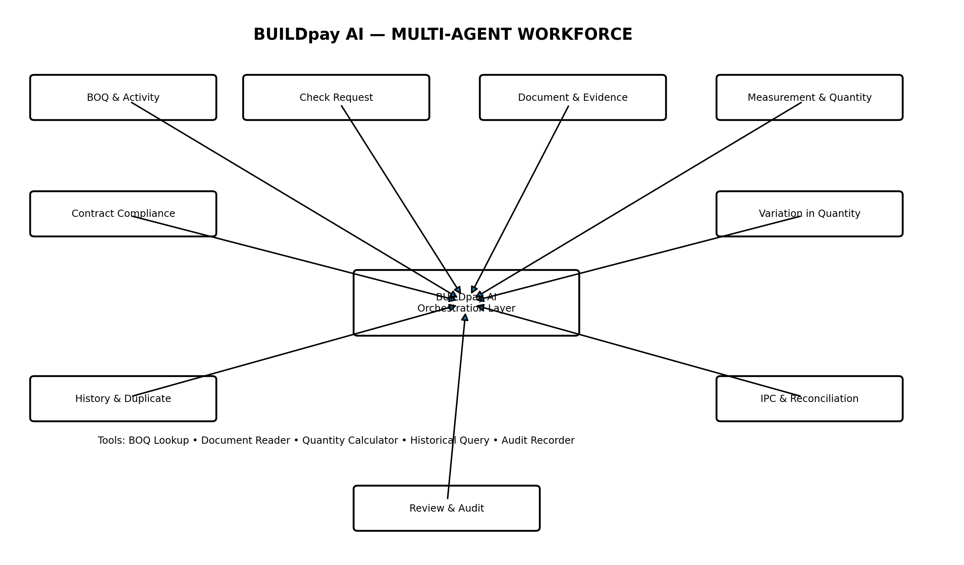
Figure 2. Multi-agent architecture and tool-assisted orchestration.
- Downloadable BOQ/IPC/report outputs.
- Progressive, simple forms.

19. Data Model
Entity | Key relationships
Project | Owns BOQs, users, CRs, variations and IPCs
BOQ | Belongs to project; contains BOQ items
BOQ Item | Referenced by CRs, measurements, variations and IPC lines
Check Request | References BOQ, documents, measurements and approvals
Document | Attached to CR, variation or IPC
Measurement | References BOQ item and CR/work
Variation | References BOQ item and originating CR; affects IPC eligibility when approved
IPC | Contains lines linked to approved work and variations
Approval | Human decision, role, timestamp and comments
Audit Event | Workflow/action history

20. Agent & Tool Architecture
Tool | Purpose
Document Reader | Extract text/data from uploaded documents.
BOQ Lookup | Retrieve exact BOQ activity, quantity, unit and rate.
Quantity/Payment Calculator | Perform deterministic quantity and amount arithmetic.
Required Document Checker | Compare required evidence with uploaded documents.
Historical Record Query | Retrieve prior CR, variation and IPC records.
Audit Recorder | Record workflow events and actions.

Financial and quantity calculations should be deterministic tool outputs, not free-form LLM arithmetic.

21. Non-Functional Requirements
Area | Requirement
Reliability | Agent errors must be visible and cannot silently create approval.
Performance | Show progress and current-agent status for long reviews.
Auditability | Material AI findings and all approvals are traceable.
Maintainability | Each agent is independently maintainable.
Extensibility | New rules/document types can be added without redesigning the UI.
Usability | Users understand status and next action.
Data integrity | Cumulative quantities and approved variations are deterministic.

22. Security & Governance
- Store API keys in Streamlit Secrets/environment configuration; never commit them.
- Production users require authentication and role-based authorization.
- Contractors cannot approve their own submissions.
- AI has no payment-release credentials.
- Uploaded documents have controlled access and retention.
- Audit records should be append-oriented.
- Production data should use managed persistent infrastructure.

23. Reporting & Analytics
- Open CRs
- Approved/returned/rejected CRs
- Pending variations
- Approved variation value
- BOQ vs revised quantity
- Current vs cumulative IPC quantities
- IPC amounts by period
- Exceptions
- Missing evidence
- Approval turnaround time
- Project payment history

24. Deployment & Technical Stack
Component | Technology
UI | Streamlit
Agent orchestration | CrewAI
LLM | Groq / openai/gpt-oss-120b
Document parsing | pypdf, python-docx, openpyxl
Prototype persistence | SQLite
Source control | GitHub
Deployment | Streamlit Community Cloud
Secrets | Streamlit Secrets
Production persistence | Managed PostgreSQL + object storage
Dependencies should be pinned and tested against the selected Python runtime. The application should remain deployable through GitHub to Streamlit Cloud.

25. MVP Acceptance Criteria
- Role workspaces function for Contractor, Consultant and Client.
- BOQ templates are available for 5 marla, 10 marla and 1 kanal double-storey civil works.
- Contractor can create CR against BOQ activity and upload evidence.
- AI agents run visibly and show current working agent.
- AI findings cover evidence, quantity, compliance and history.
- Human can approve, return or reject CR.
- Executed quantities can be recorded.
- Overruns are detected before IPC eligibility.
- Variation Register tracks proposed and approved variations.
- Variation Agent calculates and summarizes proposed additional quantities.
- Human can approve, return or reject variations.
- Only approved variations affect IPC eligibility.
- IPC can be generated from eligible approved work.
- Human can approve or return IPC.
- Previous records can be retrieved.
- Audit history records key workflow events.
- No AI action releases payment or provides final human approval.

26. Risks & Mitigations
Risk | Mitigation
AI interpretation error | Structured fields, deterministic calculations, evidence references and human approval.
Hallucinated findings | Agents use document tools and report unavailable evidence.
Quantity duplication | History agent plus deterministic cumulative calculations.
Unauthorized approval | Role-based permissions and human-only approval actions.
Data loss in prototype | Move to managed DB/object storage for production.
Agent complexity | Nine clearly bounded agents with separate modules.
Contract differences | Externalize contract rules/configuration.
Scanned documents | Add OCR/vision later with human verification.

27. Future Roadmap
Phase | Focus
MVP | BOQ, CR, evidence, human approval, variation register, IPC, history.
Phase 2 | Managed PostgreSQL, object storage, authentication and permissions.
Phase 3 | OCR/vision for scanned documents, drawings and site photos.
Phase 4 | Contract-specific rules, change orders and advanced commercial reconciliation.
Phase 5 | ERP/accounting integrations and controlled finance workflows.
Phase 6 | Portfolio analytics and advanced exception detection.

28. Open Decisions
- Which contract forms/conditions govern compliance checks?
- What documents are mandatory for each BOQ activity?
- What approval thresholds apply to each human role?
- Which retention, tax and deduction rules apply?
- How are variations classified?
- Which managed database/object storage provider will be used?
- What authentication/SSO is required?
- What document retention policy applies?
- Which currencies and tax rules must be supported?

29. Glossary
Term | Meaning
BOQ | Bill of Quantities.
CR | Check Request.
IPC | Interim Payment Certificate.
Variation | Approved change/addition to quantity or scope relative to the applicable baseline.
AI Agent | Specialized AI worker with a defined role and tools.
Human-in-the-loop | Workflow where designated humans retain decision authority.
Cumulative Quantity | Total quantity including previous and current quantities.
Approved Quantity | Quantity authorized under BOQ plus approved variations, subject to contract rules.
Evidence | Documents or records supporting a request, measurement, variation or IPC.
Audit Trail | Historical record of material system, AI and human actions/decisions.

END OF PRODUCT REQUIREMENTS DOCUMENT

Current Implementation & Deployment Update
Status: This section supersedes earlier Streamlit-specific deployment details and reflects the current BuildPay AI implementation and Azure deployment.

1. Current Application UI
BuildPay AI uses a modern Next.js 16 + React 19 frontend with TypeScript, Tailwind CSS, Radix UI components, Lucide icons, Framer Motion animations, and Recharts for data visualisation. The public experience starts at a dedicated landing page, followed by login and authenticated project-control workflows. The production UI is not a Streamlit application.

2. Backend & Data Layer
The backend is implemented with Python FastAPI and PostgreSQL database access. Authentication uses JWT-based access tokens. The application exposes REST APIs for projects, BOQ items, check requests, measurements, variations, IPC/payment workflows, documents, reports, AI findings, and audit events.

3. AI / Agent Framework Status
CrewAI is NOT used in the current BuildPay AI implementation. There is no CrewAI dependency or CrewAI-based orchestration in the repository. AI functionality follows the product principle: AI prepares, checks, calculates and flags; humans authorize. The current implementation uses the application's backend services and configured LLM integration rather than a CrewAI multi-agent runtime.

4. Azure Deployment Architecture
- Microsoft Azure Container Apps hosts the frontend and backend as separate containerised services.
- Azure Container Registry (ACR) stores the BuildPay AI frontend and backend Docker images.
- Azure Database for PostgreSQL Flexible Server provides the production relational database.
- Azure Container Apps Environment provides the shared managed container runtime and networking.
- Azure Log Analytics is associated with the Container Apps environment for application/container logs.
- The deployment uses HTTPS public ingress for the frontend and backend Container Apps.

5. Current Azure Resources
- Resource group: buildpay-ai-rg
- Container Apps environment: buildpay-ai-env
- Container Registry: buildpayaiacr5908
- Backend Container App: buildpay-backend
- Frontend Container App: buildpay-frontend
- PostgreSQL Flexible Server: buildpay-pg-3136
- Database: buildpay
- Azure region: Central India

6. Deployment Model
Both application tiers are built as Docker images. Images are pushed to Azure Container Registry and deployed to Azure Container Apps. The frontend is built with the production API base URL baked into the Next.js public environment configuration at build time. The backend receives database, JWT, LLM, and CORS configuration through Azure Container Apps environment variables and secret references rather than storing production secrets in the repository.

7. Demo & Role-Based Access
The application supports seeded demonstration accounts for Admin, Contractor, Consultant/QS, Client and Project Manager workflows. Role-based authorization remains enforced by the backend; the frontend login/demo-account UI is only a user experience layer.

8. Product Principle
BuildPay AI remains a human-in-the-loop construction project controls platform. AI assists with preparation, checking, calculations and anomaly/issue flagging, while authorized project participants retain responsibility for approvals, certifications and payments.

9. Superseded Streamlit Deployment
Any earlier section of this PRD that describes deploying BuildPay AI as a Streamlit app, including Streamlit-specific hosting, UI, startup commands or deployment instructions, should be treated as legacy project history and not as the current implementation. The authoritative deployment model is the Next.js + FastAPI + PostgreSQL stack described above, containerised with Docker and deployed on Azure Container Apps.

